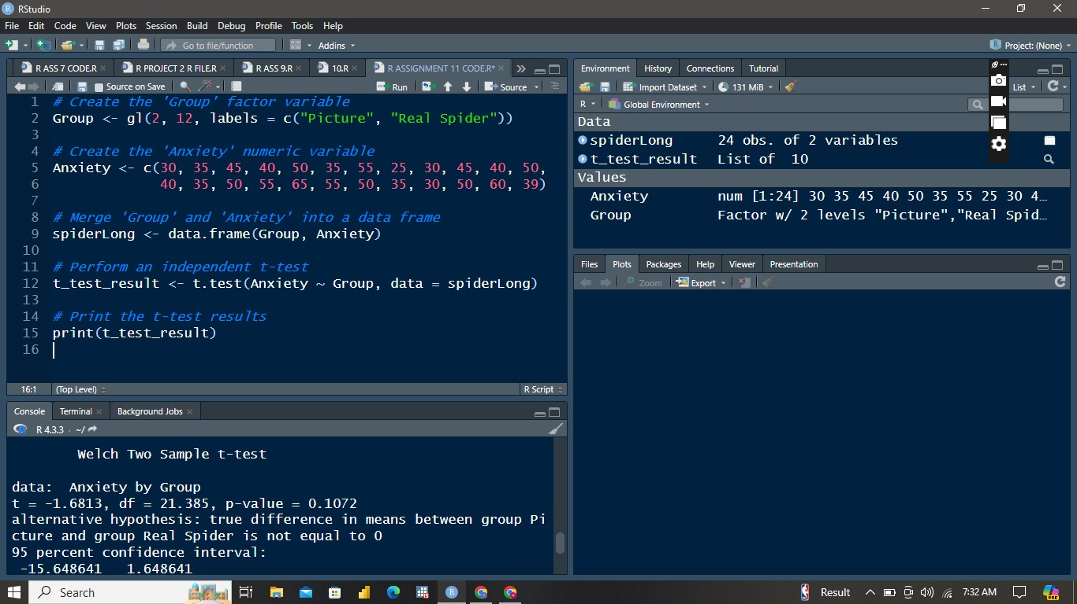

**OUPUT**

Welch Two Sample t-test

data: Anxiety by Group

t = -1.6813, df = 21.385, p-value = 0.1072

alternative hypothesis: true difference in means between group Picture and group Real Spider is not equal to 0

95 percent confidence interval:

-15.648641 1.648641

sample estimates:

mean in group Picture mean in group Real Spider

40 47

**INTERPRETATION**

**Test Statistics**

* **t-value:** -1.6813
* **Degrees of freedom (df):** 21.385
* **p-value:** 0.1072

**Hypothesis**

* **Null Hypothesis (H0):** There is no difference in the mean anxiety scores between the "Picture" group and the "Real Spider" group.
* **Alternative Hypothesis (H1):** There is a difference in the mean anxiety scores between the "Picture" group and the "Real Spider" group.

**Confidence Interval**

* **95% Confidence Interval for the difference in means:** [-15.648641, 1.648641]

**Sample Estimates**

* **Mean in group "Picture":** 40
* **Mean in group "Real Spider":** 47

**Interpretation**

1. **t-value (-1.6813):** The negative t-value indicates that the mean anxiety score for the "Picture" group is lower than that for the "Real Spider" group.
2. **Degrees of freedom (21.385):** The degrees of freedom are adjusted to account for the different variances in the two groups (Welch's t-test).
3. **p-value (0.1072):** This value represents the probability of observing the data, or something more extreme, assuming the null hypothesis is true. Since the p-value (0.1072) is greater than the common significance level of 0.05, we fail to reject the null hypothesis. This means there is not enough evidence to conclude that there is a significant difference in mean anxiety scores between the two groups.
4. **Confidence Interval (-15.648641 to 1.648641):** This range includes zero, which further indicates that there is no significant difference between the groups at the 95% confidence level. If the entire interval had been either above or below zero, it would indicate a significant difference.
5. **Sample Estimates (Means):**
   * Mean anxiety score for "Picture" group: 40
   * Mean anxiety score for "Real Spider" group: 47

These means suggest that, on average, participants exposed to a real spider had higher anxiety scores compared to those exposed to a picture of a spider.

**Conclusion**

Based on the results of the Welch Two Sample t-test, we do not have sufficient evidence to conclude that there is a significant difference in the mean anxiety scores between the "Picture" group and the "Real Spider" group (p-value = 0.1072). While there is a numerical difference in the means (40 for "Picture" and 47 for "Real Spider"), this difference is not statistically significant at the 0.05 level.